**Title:** Standardised measurement of seed functional traits: calculation of germination cardinal temperatures and thermal time using R

**Running Head:** Germination cardinal temperatures & thermal time in R

Emma Ladouceur1,2, Hugh W. Pritchard3, Eduardo Fernández-Pascual3*

1 Museo Delle Scienze (Muse), Corso del Lavoro e Scienze, 3, Trento, Italy

2 University of Pavia, Department of Earth and Environmental Science, Via S. Epifanio 14, 27100 Pavia (Italy)

3 Royal Botanic Gardens, Kew, Wellcome Trust Millennium Building, Wakehurst Place, West Sussex RH17 6TN, UK

**\*Corresponding author:** [eduardofp.indurot@uniovi.es](mailto:eduardofp.indurot@uniovi.es); Tel.: +44(0)1444894184

**Keywords (7 max):** base water potential, physiological thermal thresholds, piecewise regression, regeneration traits, seed germination traits, segmented model, thermal time models

**Author Contribution Statement:** EL conceived the idea, EFP refined the idea into a standardised R method, and EFP and EL revised the method together. EFP provided the dataset. HWP and EFP provided expertise relating to the fundamentals behind the thermal time approach. EL led the writing of the manuscript. All authors contributed critically to the drafts and gave final approval for publication.

**Summary**

1. Seed germination traits have emerged as a powerful mechanism to understand plant ecology and regeneration in a changing world. Physiological thermal time models quantify germination traits and provide a strong comparative framework. The models estimate three cardinal temperatures (base threshold, Tb; optimum, To; and ceiling threshold, Tc), and thermal time (θ50). Traditionally, calculating these traits has required user judgement, which is time consuming and introduces bias into the analysis. Standardisation of trait measures is needed to estimate and utilize germination traits to full potential in comparative studies and global meta-analyses.
2. Here, we present a straightforward method to calculate these traits with R which has three main benefits; it (1) systematic identification of the breaking point in the data (i.e. the separation between the sub-optimal and supra-optimal germination temperature ranges), avoiding personal bias; (2) rapid computation; and (3) free, open-source statistical software.
3. We provide the R script to conduct the analysis. To demonstrate common issues and offer solutions, the example dataset includes one experiment with data sufficient for calculating the cardinal temperatures, and one experiment with data which were insufficient. We also provide detailed notes to introduce new users to R. Finally, we briefly discuss guidelines for designing cardinal temperature experiments, as well as to store and share the results of germination studies. This material will encourage co-operative meta-analyses of seed germination, linking seed biology with broader fields of plant science.

**Introduction**

There is a rapidly developing demand for seed germination traits in the plant sciences; including population ecology (Huang *et al.* 2016), community assembly (Larson & Funk 2016), biogeography (Bykova *et al.* 2012), and ecological restoration (Larson *et al.* 2014). Of prime interest is the contribution that large germination datasets can make to the development of mechanistic trait-based models that predict how plant diversity responds to global environmental changes (Funk *et al.* 2016). Germination traits are however underrepresented in public trait databases (Jiménez-Alfaro *et al.* 2016). Filling this gap is best achieved through comparative studies, but the value of these will only be optimised if there is a consistent approach to the generation of data on germination phenotypes and robust means of analysing the outputs. A solid comparative framework for germination studies is offered by the application of physiological thermal time models (Dürr *et al.* 2015; Donohue *et al.* 2015).

Germination occurs in response to a series of environmental cues including temperature, moisture, light and chemical signals (Bewley *et al.* 2013). For each of these cues there is an optimal value (or sometimes a narrow range) at which the rate of germination is maximal. Below and above this optimum, the rate progressively decreases until the cue reaches estimated base and ceiling thresholds beyond which the progression of germination is predicted to stop. Thus, the rate of germination as a function of temperature can be described in non-dormant seeds as an accumulation of degree-days above or below these thresholds (García-Huidobro *et al.* 1982). When a certain amount of degree-days has been accumulated, the seed germinates. Therefore, the thermal control of germination can be described in a mechanistic way using four seed traits: the three cardinal temperatures (base thermal threshold = Tb, optimal temperature = To, and ceiling thermal threshold = Tc); and the thermal time required for 50 % germination (θ50).

Nevertheless, the thermal time methodology was originally developed with agricultural varieties that tend to show low dormancy, fast germination, and low within-species trait variation {Durr:2015kd}. Wild species usually have the opposite features, and many times ecologists are faced by a lack of *a priori* knowledge on the germination traits of the species that occur in the communities that they are studying. This lack of knowledge prevents them from choosing the right temperature treatments or scoring dates when designing their experiments, and so the data produced is rarely good enough to calculate the more advanced thermal time models, based on the distribution of thermal times across subpopulations of the sample {Hardegree:2006ga}. For this reason, we propose to use the thermal time calculated for the 50 % subpopulation (i.e., °C d G50)as a standard measure of germination. The use of this standard allows to use data produced in relatively simple experiments to compare individuals, populations, species and plant communities (Trudgill *et al.* 2000; Dürr *et al.* 2015).

The purpose of the tool we present here is to facilitate to plant ecologists the inclusion of germination traits in their studies, rather than the calculation of more precise thermal time models in specialised seed or agricultural research. We present a standardised method to calculate germination cardinal temperatures and thermal time using segmented regression in the open-source software *‘R statistical computing language and platform’* (R Core Development Team 2016). This method has three advantages over methods currently in use: it (1) identifies systematically the breaking point in the data (i.e., the separation between the sub-optimal and supra-optimal germination temperature ranges), rather than the user estimating breaking points visually and on a case-by-case basis, which can lead to personal bias; (2) is computed rapidly, in contrast to the time-consuming case-by-case approach of alternative methods; and (3) does not require the purchase of commercial statistical software. We show this method calculating cardinal temperatures in two example datasets: one in which the three cardinal temperatures can be identified, and one in which experimental results did not lead to the successful identification of all the cardinal temperatures. We present here the format in which the data should be arranged (**S1 Example Data**), the script to analyse the data (**S 2 R Script**) and basic instructions for users new to *R* (**S3 Introductory Instructions**) to complete the workflow of this method **(Table 1)**. Our aim is to make this method accessible, completely transparent, and rigorously reproducible by all researchers (Rocchini & Neteler 2012).

**Description of the method**

*Data preparation*

We provide an example dataset (**Supplementary Information 1**) with germination results from a previous article (Fernández-Pascual *et al.* 2015). Users should format their data in the same way, keeping original column names. The first column, *Grouping*, represents an experimental factor other than temperature. In the example this factor is species, with two levels *species A* and *species B*. *Grouping* can also represent different individuals, populations or experimental treatments, depending on the data being analysed. When users have more than one grouping factor in their data (e.g., ‘Population’ and ‘Stratification’), the two factors should be combined in one *Grouping* column (e.g., ‘Population.Stratification’). Although the example is presented with two species, the script is prepared to analyse larger numbers of factor levels. The second column, *Treatment*, records the range of temperatures each species was tested by. The third column, *Dish*, indicates the Petri dish (or other container) number. In this example, there is only one *Dish* for each *Treatment*. In other cases, where an experiment may have several *Dishes* per treatment, the script will work in the same way. The fourth column, *Time*, is the time in which each data point was recorded (in days in this example, but it could be hours or any other unit of time). The fifth column, *G*, indicates the cumulative germination count at that scoring date. The sixth column, *PG*, indicates the total sample size of each Petri dish, which in this case is 25 seeds. If a proportion of seeds do not germinate by the end of a test, they may be empty, dead, or simply dormant. These categories should be distinguished through cutting or another test. The number in PG should always be the number of germinable seeds in the dish including dormant but not empty or dead seeds.

*R and R packages needed*

All analyses are performed in R(R Core Development Team 2016). The script (**Supplementary Information 2**) presents the method and, when used with the example dataset (**Supplementary Information 1**), produces four tables and four figures that we will describe below. For users who are new to R, we have prepared the essential information to get started in **Supplementary Information 3***.* Before performing the analyses, six specialist R packages must be installed: ‘plyr’and *‘*dplyr’ (Wickham *et al.* 2016) are used for data manipulation;‘binom’ (Dorai-Raj, 2014) is used to calculate binomial confidence intervals on the germination proportions; ‘drc’ (Ritz *et al.* 2015) is used to fit dose-response models to cumulative germination data, in order to calculate the germination times and rates; ‘segmented’ (Vito 2008) is used to fit a segmented regression and compute the cardinal temperatures and thermal times; and ‘ggplot2’ is used to create figures (Wickham 2009).

*Step 1: Checking whether the data represents the full germination temperature range*

A preliminary analysis is done with the results of the final scoring date (i.e., the final germination proportions). The mean final germination proportions and their 95 % binomial confidence intervals are calculated for each combination of *Grouping* and *Treatment*. This information is exported as **Table S1**. The final germination proportions are also plotted as **Figure 1**, which needs to be inspected visually for evidence that the temperature treatments used in the experiment do represent the full germination temperature range of the study species. If this is the case, the segmented model can be fitted and used to calculate the three cardinal temperatures. This would be the case in species A, for which we generated data representing the full range of germination temperatures (**Figure 1A**). However, when the experimental treatments only give results in either the sub- or the supra-optimal germination temperature range, the segmented model cannot be fitted and only the base or ceiling temperatures can be calculated. This is the case in species B*,* where there was no germination above the treatment with the highest germination, ‘23.75 ºC’ (**Figure 1B**). Thus, for species B we only have data in the sub-optimal germination temperature range.

*Step 2: Estimating germination rates from the cumulative germination curves*

A dose-response model is fitted to the cumulative germination data, in which time is the dose and germination is the response. This model is used to estimate the time required to reach successive germination proportions. This is the most sensitive part of the analysis, as poor estimations of the germination times will lead to less accurate cardinal temperatures and thermal times. There are several dose-response functions that can be fitted to this type of data: Weibull, logistic or Boltzmann, and log-logistic or Hill (Ritz *et al.* 2015). For each combination of grouping and treatment, the script selects the function with the best fit to the data using Akaike’s Information Criterion (AIC). This is expected to give more accurate estimations of the germination times than applying the same function across treatments. Nonetheless, the function fits need to be checked visually in **Figure 2**. It is possible that no good fit can be found; for example, if final germination is very low or if the scoring times were inadequate (e.g., if germination is scored every 24 h but all seeds germinate within the first 24 h). If this is the case, cardinal temperatures and thermal time cannot be calculated, and we suggest to repeat the experiment with new treatments or a move-along design (Baskin & Baskin 2003) to learn more about the species before attempting another trial aimed at the specifics of cardinal temperatures.

If the models can be fitted, they are used to calculate the time to reach successive deciles of germination (from 10 to 90 %) in each treatment. The inverse of the time is then calculated to obtain the germination rates of each temperature treatment, and this information is exported as **Table S2**. We propose to use preferably the values calculated for 50 % germination as reference traits that offer the most stable results for comparative studies and meta-analyses. However, the script calculates the nine deciles from 10 to 90 % germination because (1) some researchers may want this information to conduct further thermal time analyses, and (2) in some experiments 50 % germination is never reached, and thus calculations cannot be made for this decile.

*Step 3a: Fitting a segmented model to the full germination temperature range*

Where sub-optimal and supra-optimal temperatures are available in the data set (**Figure 1A**), the script can calculate the three cardinal temperatures (Tb, To and Tc) and the thermal time (θ-sub, θ-supra). In this scenario, a segmented regression model is fitted to the data (**Figure 3A**). A segmented model identifies breaking points in the data (i.e., the optimal germination temperature at which the germination rate is maximal). Then the model fits linear regressions separately to the two segments defined by this breaking point (*i.e*., the sub-optimal and supra-optimal germination temperature ranges) (**Figure 3A**). Once the models are fitted, the base temperature (Tb) is calculated by solving the sub-optimal linear regression for the x-intercept (i.e., the temperature in which the value of the germination rate equals zero). An analogous procedure calculates the Tc using the supra-optimal linear regression. The intercept of the sub-optimal and supra-optimal lines gives the To. The inverse of the slopes of each regression gives the estimated thermal time for germination in degree-days (or the time unit used in the data). The script calculates the cardinal temperatures and thermal times for each of the nine decile germination rates (10 – 90 %) and exports this information as **Table S3**. This table also includes the intercept and slopes of the regressions, their standard errors and p-values, the number of temperature treatments used to fit the model, and the adjusted R2 of the segmented model. The plots with the germination rate versus temperature and the fitted models for every decile are exported as **Figure 3**.This figure needs to be carefully inspected to detect doubtful fits and outlier temperatures, which should be removed from the dataset in order to calculate accurate cardinal temperatures and thermal time. It must be considered that, when dealing with wild species with a certain degree of dormancy, the cardinal temperatures calculated for the lower and higher germination deciles can give extreme results. Because of this, the parameters estimated for the t50 are probably the most robust trait to report in comparative analyses.

It may be the case that the temperatures used in a given experiment fall only on the sub-optimal or supra-optimal germination temperature range, and do not succeed to identify the full range of temperatures (**Figure 1B**). In this case, the dataset **Table S3** cannot be produced. In the example of species B, it is impossible to determine neither the Tc nor the To, and the segmented model cannot be fitted to the data (**Figure 3B**). In this scenario, it would be necessary to skip forward to the next step in the script.

*Step 3b: Fitting a linear model to the sub- or supra-optimal germination temperature range*

In the case of species B, or any experiment which fails to identify the full range of temperatures (**Figure 3B**), a standard linear regression can be used to identify either the Tb or the Tc. The inverse of the slope of this regression gives the thermal time for germination in degree-days (or the time unit used in the data). To perform these analyses, the script identifies a provisional breaking-point temperature as the temperature with the highest germination rate, divides the germination temperature range in two segments separated by this temperature, and fits linear regressions to each segment. This approach is more similar to the one traditionally used in thermal time analyses. The output of the models is exported as **Table S4** which will automatically include information for whichever single segment was identified in each unique dataset, either the sub-optimal or the supra-optimal (note that, if the segmented model was successfully fitted, this alternative step will also calculate parameters for the two segments). This table also includes the intercept and slopes of the regressions, their standard errors and p-values, the number of temperature treatments used in each fit, and the adjusted R2 of the two linear regressions. The plot of these linear fits (**Figure 4**) must be visually inspected to detect outliers.

It must be noted that this part of the script can also be used to calculate the germination base water potential (REFERENCIA). In this case, the dataset that is being analysed would represent an experiment of germination in different water potential solutions. The values of the column *Treatment* would be the water potentials instead of the temperatures. Values of Tb in **Table S4** would refer to the base water potential.

**Discussion**

*How to use the script*

The method we have presented above is appropriate for the analysis of germination data to identify cardinal temperatures and thermal time, and can also be used to calculate base water potential. Once users have become familiar with the script, running the method is fast and straightforward. Users just needs to place the script and formatted dataset in their R working directory, and run the script within R. The script will perform all calculations and export the results as four tables and four figures ready for publication.

*Experimental designs for standardised thermal time*

An experimental design to identify the cardinal temperatures and thermal time should be tailored to include the breadth of the germination temperature range. The aim should be to generate data points purposefully below the optimal (sub-optimal) and well above the optimal germination temperature (supra-optimal), pushing each species to its extreme thermal thresholds. Fitting a segmented model requires a minimum of three sub-optimal and three supra-optimal temperatures. It is thus recommended that experimental designs include a minimum of 5 temperatures for each temperature range to effectively explore the limits, in which case some temperatures may not yield responses. The less that is known about a given species from the outset, the more temperatures that should be tested.

Constant temperature treatments are known to produce promising results for measuring cardinal temperatures, particularly for agricultural varieties which have been bred for uniformity and stable germination temperatures (Covell *et al.* 1986). Nevertheless many wild species may require alternating temperatures, or alternating temperatures may better represent real ambient conditions found in nature (Fernández-Pascual *et al.* 2015; Galíndez *et al.* 2017). When testing with alternating temperatures, it is possible to run the analyses by inputting the temperature regimes as the average of the two phases (Ellis & Barret 1994). However, this approach might not be correct if one of the two phases falls below the base temperature or above the ceiling temperature, since the seeds would not accumulate thermal time during this phase. Thus, alternating temperature regimes should be carefully planned to avoid exceeding the cardinal temperature range. Constant temperatures should never be compared to alternating temperatures within the same analysis or *Treatment*, but if testing both, the two temperature regimes should be set up as two experiments or *Groupings*, to compare against each other. Ideally, in setting up an experimental design for wild species, a regime of both constant and alternating temperatures could be tested separately, and the results compared.

Experiments are recommended to be run until cumulative germination reaches a plateau. Scoring dates should be adjusted to the speed of germination of the study species, so cumulative germination curves with good resolution are produced. Finally, it is important to consider that the cardinal temperatures are not fixed values but depend on the dormancy state of the seed lot, as affected by any pre-treatment or variation in developmental time (Pritchard *et al.* 1999; Daws *et al.* 2004). Generally, non-dormant seeds with high germination percentages are needed to produce robust estimations of the cardinal temperatures and the thermal time.

Regardless of the data analysis that is being pursued, we strongly encourage seed researchers to adopt the format proposed here (**Supplementary Information 1**) when storing and sharing their original germination data. This format - in which each data record is a row, and each variable is a column – is the standard used by most statistical languages, including R. Using this standard for record keeping would improve the communication within seed research and with other scientific fields. Moreover, we propose the policy of making these standardised records available to the public as supplementary material of the publications in which they are first reported. This would ensure that data from single species studies can be incorporated into meta-analyses of seed germination, to the common benefit of seed science.

*Conclusions*

We have found and confirmed that this method is useful to calculate thermal time and cardinal temperatures in germination experiments which have tested a full range of temperatures across a given species germination gradient. Physiological thresholds such as the cardinal temperatures are highly informative plant traits, and a key tool to integrate plant regeneration into multi-species community studies (Jiménez-Alfaro *et al.* 2016; Larson & Funk 2016). We believe that this method will be of great value to generate cardinal temperature data for an ever-increasing number of species, setting a standardised methodology for the consistent measurement of species germination traits.

**Acknowledgements**

Special thanks to Maria Tudela Isanta of the NAtive Seed Science TEchnology and Conservation (http://NASSTEC) Initial Training Network (ITN) for helping to test the script leading to a much improved method and manuscript. The research leading to these results has received funding from the People Programme (Marie Curie Actions) of the European Union's Seventh Framework Programme FP7/2007-2013/ under REA grant agreement n°607785. E.F.P. had the financial support of the Government of Asturias and the FP7 – Marie Curie - COFUND programme of the European Commission (Grant ‘Clarín’ ACA14-19) to work at the Royal Botanic Gardens, Kew, which also receives grant-in-aid from Defra.

**References**

Baskin, C.C. & Baskin, J.M. (2003). When breaking seed dormancy is a problem try a move-along experiment. *Native Plants Journal*, **4**, 17–21.

Bewley, D.J., Bradford, K.J., Hilhorst, H.W.M. & Nonogaki, H. (2013). *Seeds Physiology of Development Germination and Dormancy*, Third Edition. Springer, New York.

Bykova, O., Chuine, I., Morin, X. & Higgins, S.I. (2012). Temperature dependence of the reproduction niche and its relevance for plant species distributions. *Journal of Biogeography*, **39**, 2191–2200.

Covell, S., Ellis, R.H., Roberts, E.H. & Summerfield, R.J. (1986). The influence of temperature on seed germination rate in grain legumes. *Journal of Experimental Botany*, **37**, 705–715.

Daws, M.I., Lydall, E., Chmielarz, P., Leprince, O., Matthews, S., Thanos, C.A. & Pritchard, H.W. (2004). Developmental heat sum influences recalcitrant seed traits in *Aesculus hippocastanum* across Europe. *New Phytologist*, **162**, 157–166.

Donohue, K., Burghardt, L.T., Runcie, D., Bradford, K.J. & Schmitt, J. (2015). Applying developmental threshold models to evolutionary ecology. *Trends in Ecology & Evolution*, **30**, 66–77.

Dorai-Raj, S. (2014) binom: Binomial Confidence Intervals For Several Parameterizations. R package version 1.1-1.

Dürr, C., Dickie, J.B., Yang, X.Y. & Pritchard, H.W. (2015). Ranges of critical temperature and water potential values for the germination of species worldwide: contribution to a seed trait database. *Agricultural and Forest Meteorology*, **200**, 222–232.

Ellis, R.H. & Barret, S. (1994). Alternating temperatures and rate of seed germination in lentil. *Annals of Botany*, **74**, 519–524.

Fernández-Pascual, E., Seal, C.E. & Pritchard, H.W. (2015). Simulating the germination response to diurnally alternating temperatures under climate change scenarios: comparative studies on *Carex diandra* seeds. *Annals of Botany*, **115**, 201–209.

Funk, J.L., Larson, J.E., Ames, G.M., Butterfield, B.J., Cavender-Bares, J., Firn, J., Laughlin, D.C., Sutton-Grier, A.E., Williams, L. & Wright, J. (2016). Revisiting the Holy Grail: using plant functional traits to understand ecological processes. *Biological Reviews*, **(Early View)**.

Galíndez, G., Seal, C.E., Daws, M.I. & Lindow, L. (2017). Alternating temperature combined with darkness resets base temperature for germination (Tb) in photoblastic seeds of *Lippia* and *Aloysia* (Verbenaceae). *Plant Biology* **19**, 41–45.

García-Huidobro, J., L, M.J. & Squires, G.R. (1982). Time, temperature and germination of pearl millet (*Pennisetum typhoides* S. & H.). *Journal of Experimental Botany*, **33**, 288–296.

Huang, Z., Liu, S., Bradford, K.J., Huxman, T.E. & Venable, L.D. (2016). The contribution of germination functional traits to population dynamics of a desert plant community. *Ecology*, **97**, 250–261.

Jiménez-Alfaro, B., Silveira, F.A.O., Fidelis, A., Poschlod, P. & Commander, L.E. (2016). Seed germination traits can contribute better to plant community ecology. *Journal of Vegetation Science*, **27**, 637–645.

Larson, J.E. & Funk, J.L. (2016). Regeneration: an overlooked aspect of trait-based plant community assembly models. *Journal of Ecology*, **104**, 1284–1298.

Larson, J.E., Sheley, R.L., Hardegree, S.P., Doescher, P.S. & James, J.J. (2014). Seed and seedling traits affecting critical life stage transitions and recruitment outcomes in dryland grasses. *Journal of Applied Ecology*, **52**, 199–209.

Muggeo, V.M.R. (2003) Estimating regression models with unknown break- points. Statistics in Medicine, 22, 30553071.

Muggeo, V.M.R. (2008) Segmented: an R package to fit regression models with broken-line relationships. R News 8/1, 2025.

Orrù, M., Mattana, E., Pritchard, H.W. & Bacchetta, G. (2012). Thermal thresholds as predictors of seed dormancy release and germination timing: altitude-related risks from climate warming for the wild grapevine *Vitis vinifera* subsp. *sylvestris*. *Annals of Botany*, **110**, 1651–1660.

Pritchard, H.W., Steadman, K.J., Nash, J.V. & Jones, C. (1999). Kinetics of dormancy release and the high temperature germination response in *Aesculus hippocastanum* seeds. *Journal of Experimental Botany*, **50**, 1507–1514.

R Core Development Team. (2016). R: A language and environment for statistical computing. R Foundation for Statistical Computing, Vienna. URL http://r-project.org [accessed 6 December 2016]

Ritz, C., Baty, F., Streibig, J.C. & Gerhard, D. (2015). Dose-Response Analysis Using R. *PLoS ONE*, **10**, 1–13.

Rocchini, D. & Neteler, M. (2012). Let the four freedoms paradigm apply to ecology. *Trends in Ecology & Evolution*, **27**, 310–311.

Trudgill, D.L., Squire, G.R. & Thompson, K. (2000). A thermal time basis for comparing the germination requirements of some British herbaceous plants. *New Phytologist*, **145**, 107–114.

Wickham, H. (2009). *ggplot2: Elegant Graphics for Data Analysis*. Springer-Verlag, New York.

Wickham, H., Francois, R.Francois. (2016). dplyr: A grammar of data manipulation. R package version 0.5.0.

**Table 1:** Workflow to follow associated objective of each step labelled in both the manuscript and the *R* script.

|  |  |  |  |  |
| --- | --- | --- | --- | --- |
|  | Step 1 | Step 2 | Step 3a | Step 3b |
| Objective | Check full temperature range | Estimate Germination Rate | Fit segmented model (with full range of data) | Fit linear model for sub & supra temperatures |
| Table | S1 Final germination proportions | S2 Germination rates | S3 Segmented model | S4 Linear models |
| Figure | Figure 1 Final Germination Proportions | Figure 2 Cumulative Germination Temperature Curves | Figure 3a Segmented Models | Figured 3b Linear Models |

C:\Users\Edu\AppData\Local\Microsoft\Windows\INetCacheContent.Word\Fig 1 Final germination percentage.tiff

**Figure 1** Final germination percentages across all temperature treatments for species A and species B. Bars represent the final germination percentage of each temperature treatment, brackets represent the binomial confidence interval of every treatment.

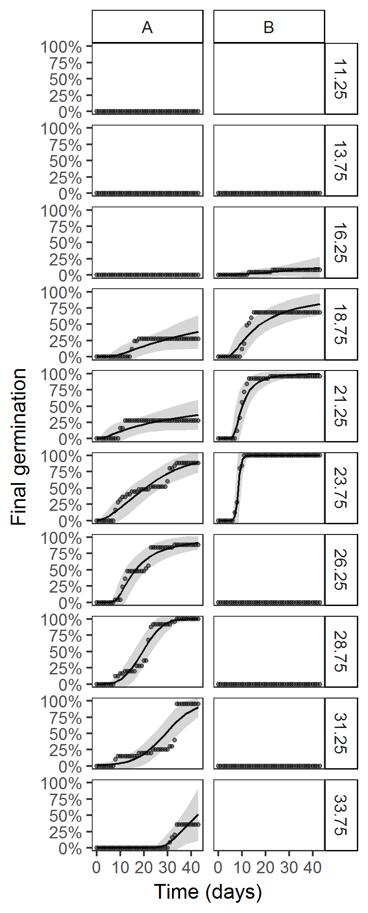

**Figure 2** Cumulative germination curves across all temperature treatments for species A and species B. Points represent cumulative germination percentages at each scoring time, lines represent the best fit dose-response model to the scoring days, areas represent the confidence interval of the dose-response models.

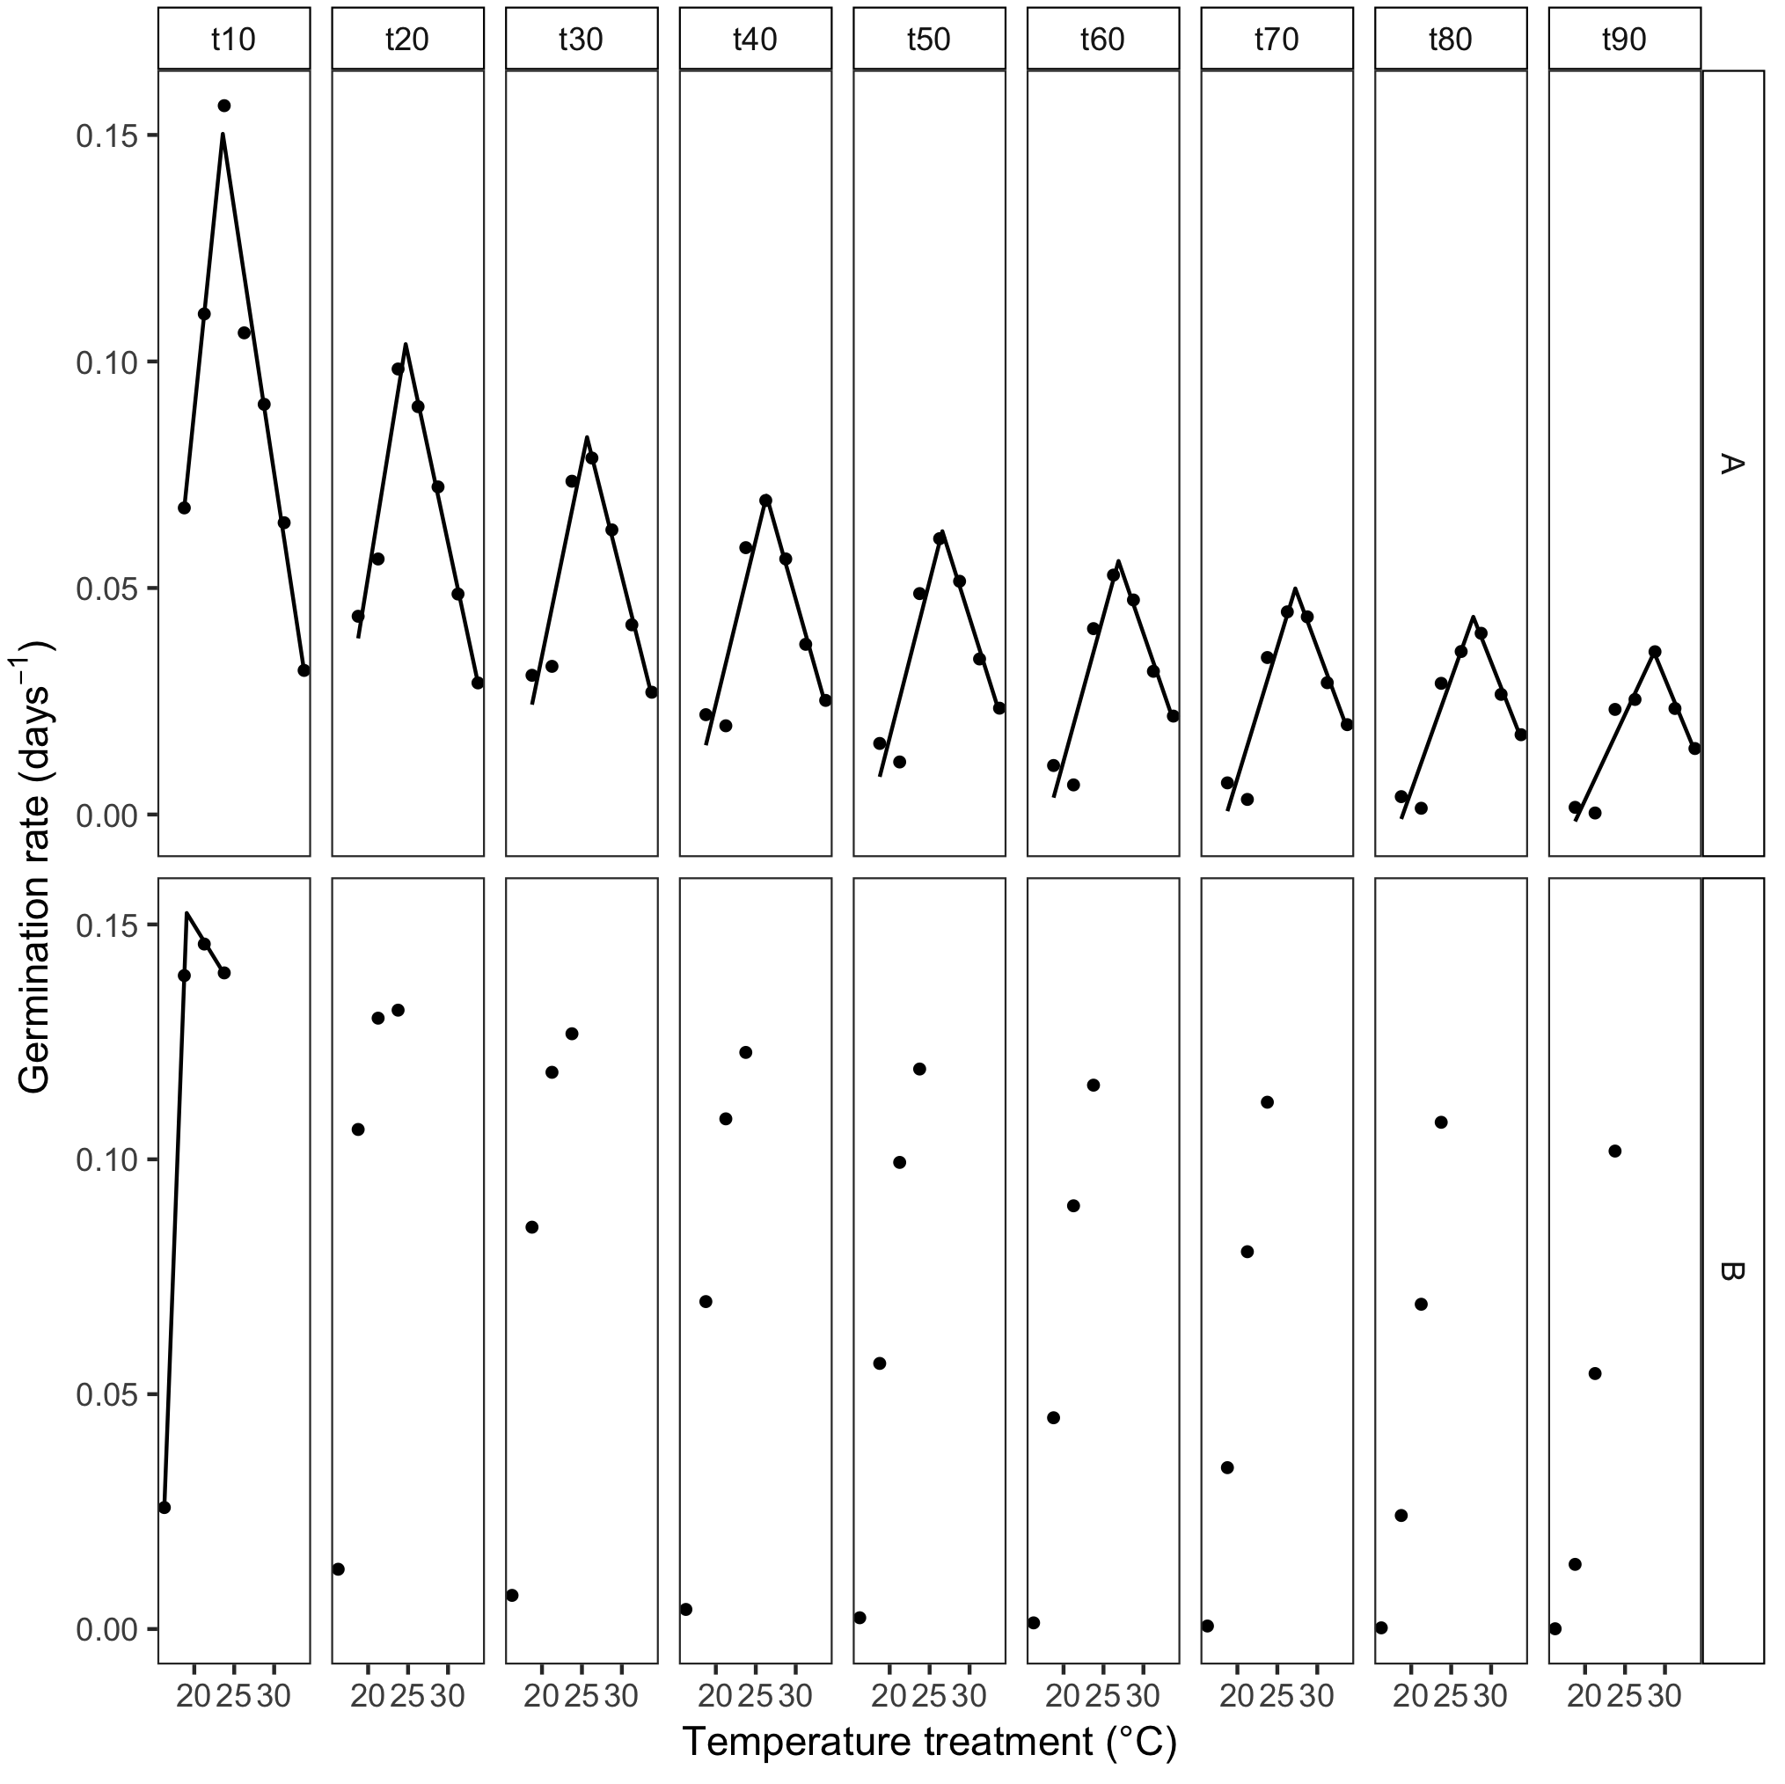

**Figure 3** Segmented models fitted to germination rate vs temperature. Models were fitted separately for each decile and for species A and species B. Points represent the germination rate for every temperature treatment, and lines represent the fit of the segmented model to the points.

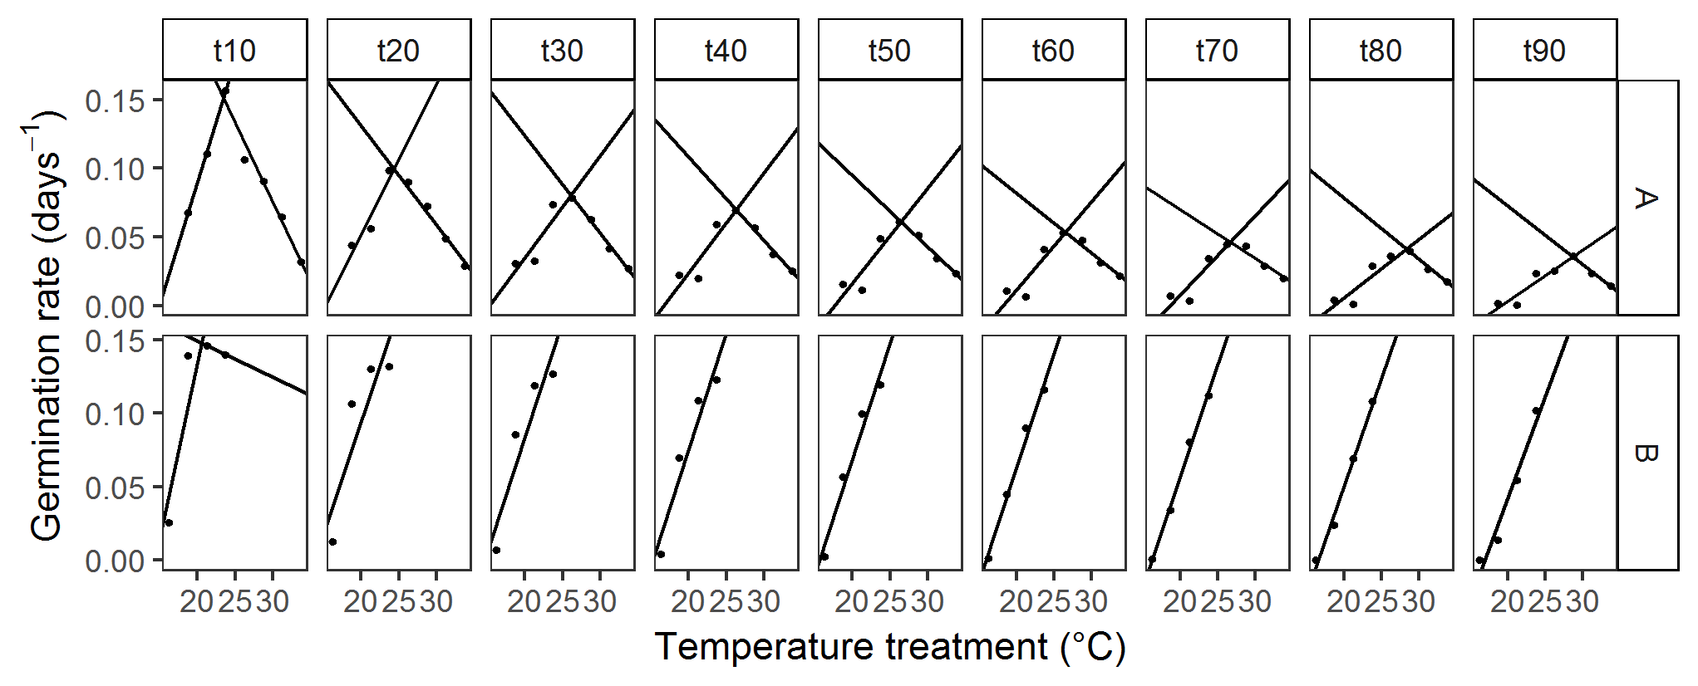

**Figure 4** Linear models fitted to germination rate vs temperature. Models were fitted separately for each decile and for species A and species B. Points represent the germination rate for every temperature treatment, and lines represent the fit of the linear model to the points.

**Supporting information**

**Supporting information 1** Example dataset to try the analyses.

**Supporting information 2** Annotated R script to conduct the analyses.

**Supporting information 3** Basic instructions for users new to R.

**Table S1** Final germination proportions. For each grouping and treatment, the table includes the number of germinated seeds (x), the number of germinable seeds (n), the average germination proportions (mean) and the limits of the 95 % binomial confidence interval (lower, upper).

**Table S2** Germination times and rates for each decile of each grouping and treatment. The best fit dose-response models and its value of Akaike’s Information Criterion (AIC) are indicated.

**Table S3** Segmented regression models fitted to each decile of each grouping. The table includes the maximal germination rate (GRmax); the temperature treatment giving this maximal rate (Treatment.max); the optimal germination temperature estimated as the breaking point of the segmented model (To); the number of temperatures used in fitting the model (n); the adjusted R2 of the model; the intercepts and slopes of the two segments including their standard errors, t and p-values; the estimated base and ceiling germination temperatures (Tb, Tc) and the thermal time estimated for each segment (thetasub, thetasupra).

**Table S4** Linear regression models fitted to each decile of each grouping. The table includes the maximal germination rate (GRmax); the temperature treatment giving this maximal rate (Treatment.max); the optimal germination temperature estimated as the intercept of the two models (To); the number of temperatures used in fitting each of the two linear regressions (n.sub, n.supra); the adjusted R2 of each regression; the intercepts and slopes of the two segments including their standard errors, t and p-values; the estimated base and ceiling germination temperatures (Tb, Tc) and the thermal time estimated for each segment (thetasub, thetasupra).